Introduction to CloudWatch

Term | Meaning (Simple)
CloudWatch | Monitoring service
Metric | A measurable value (CPU, Network, Disk)
Namespace | Group of metrics
Alarm | Rule that watches metrics
SNS | Service to send notifications

aunch a Linux EC2 instance
- Go to EC2
- Click Launch instance
- Name:
- cloudwatch-demo-instance
- AMI: Amazon Linux
- Instance type: t2.micro
- Key pair: select or create
- Security group: allow SSH
- ✅ Enable detailed monitoring (IMPORTANT)
- Click Launch instance

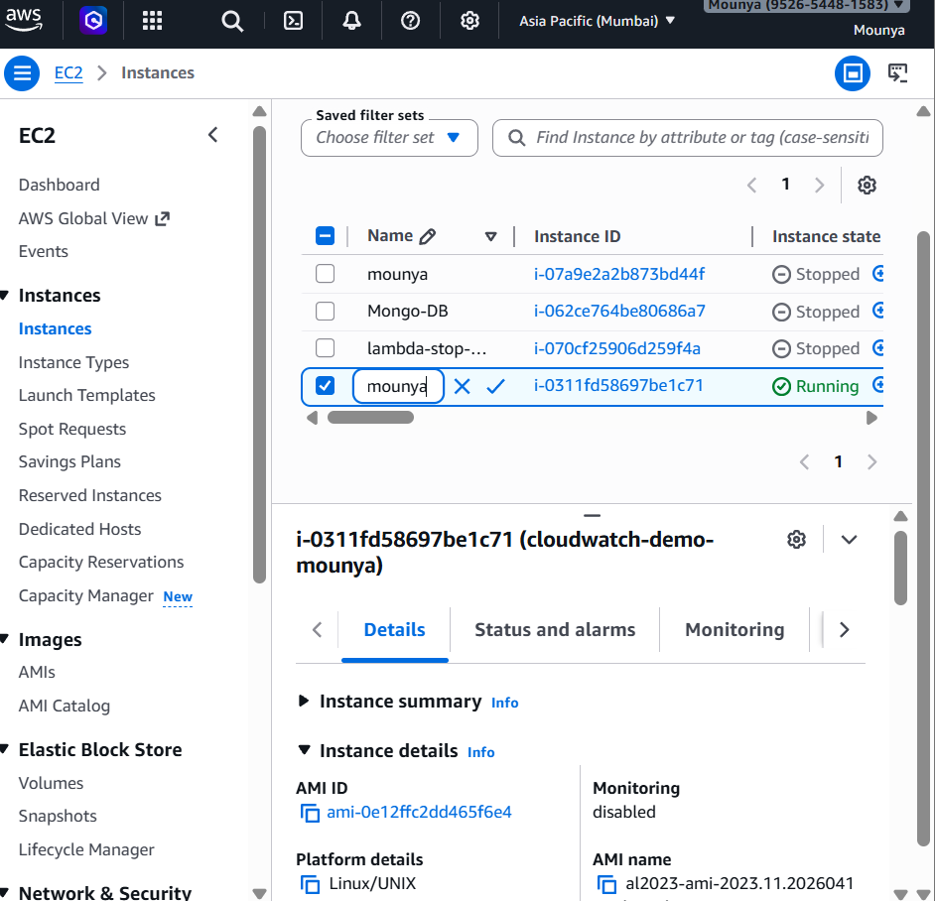

View EC2 metrics
- Go to EC2 → Instances
- Select your instance
- Click Monitoring tab
You will see graphs for:
- CPU Utilization ✅
- Network In / Out
- Disk activity
✅ This is CloudWatch in action
EC2 automatically sends basic metrics to CloudWatch
You don’t need to install anything for CPU metrics

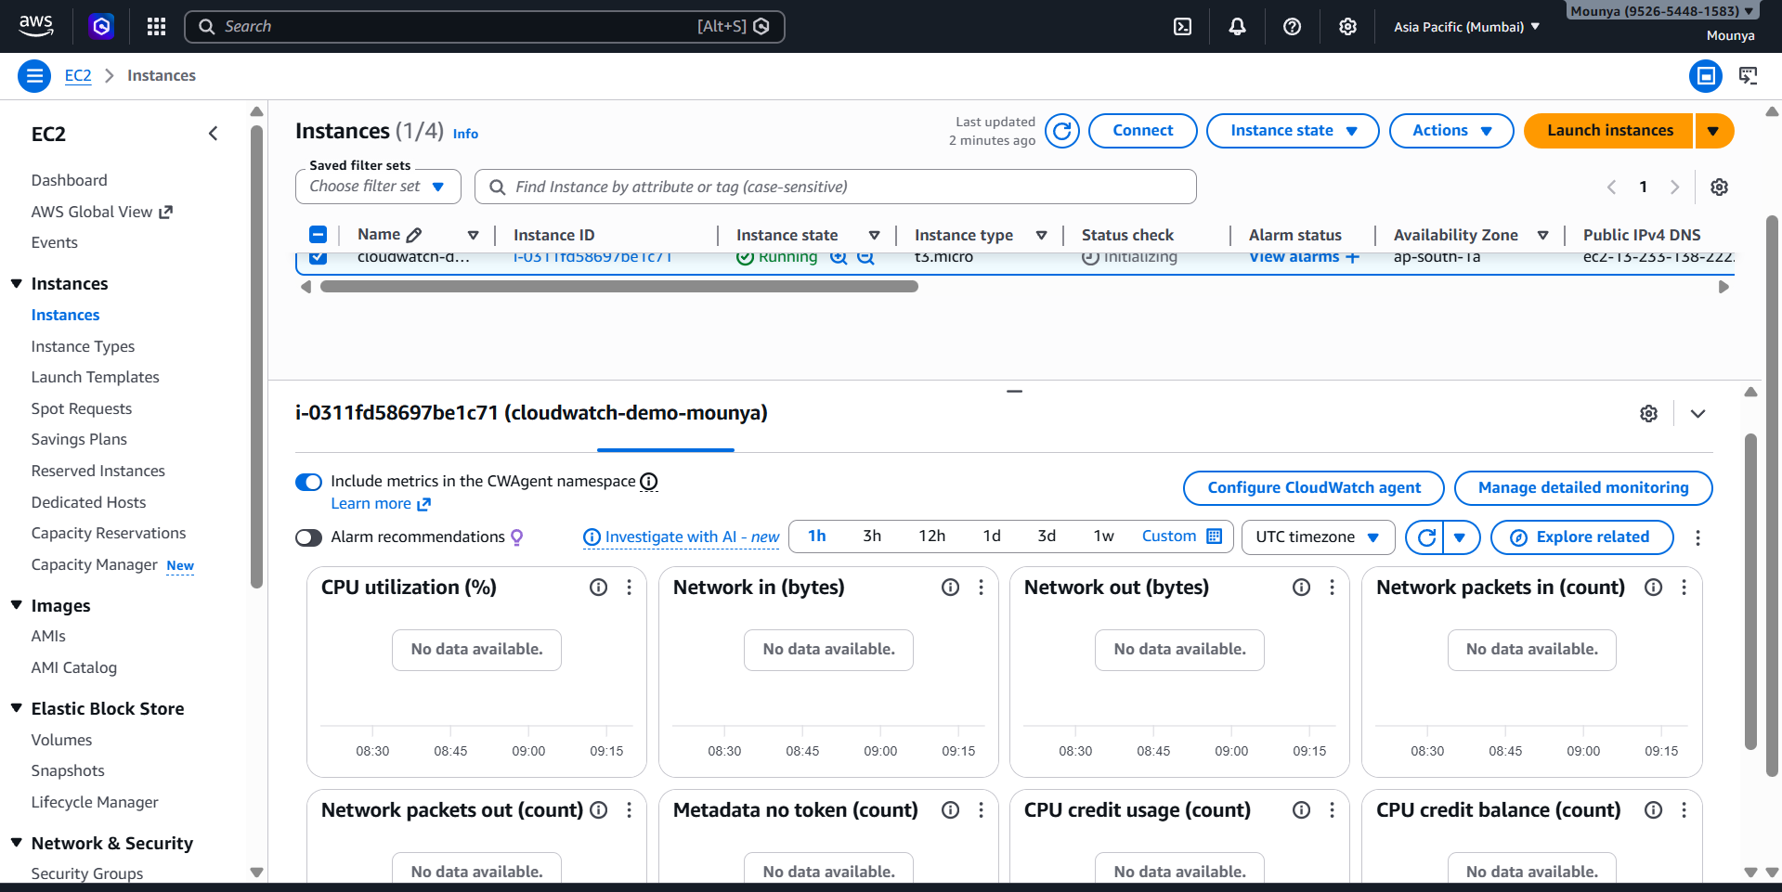
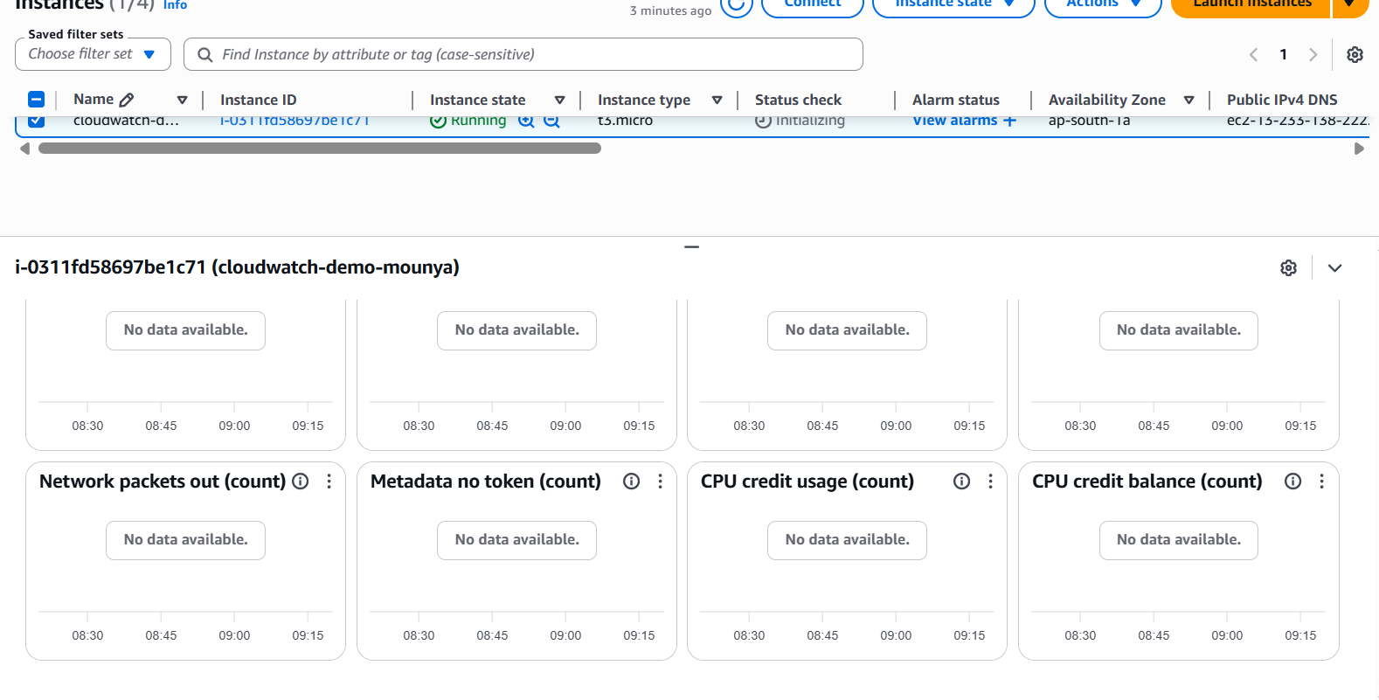
• Go to SNS
• Click Topics
• Click Create topic
• Type: Standard

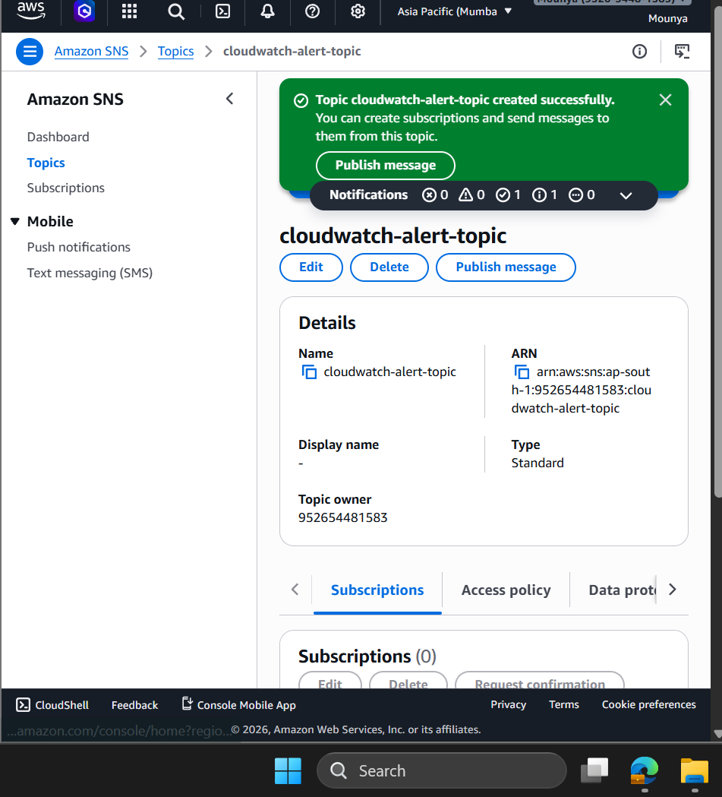
• Go to SNS
• Click Topics
• Click Create topic
• Type: Standard
•
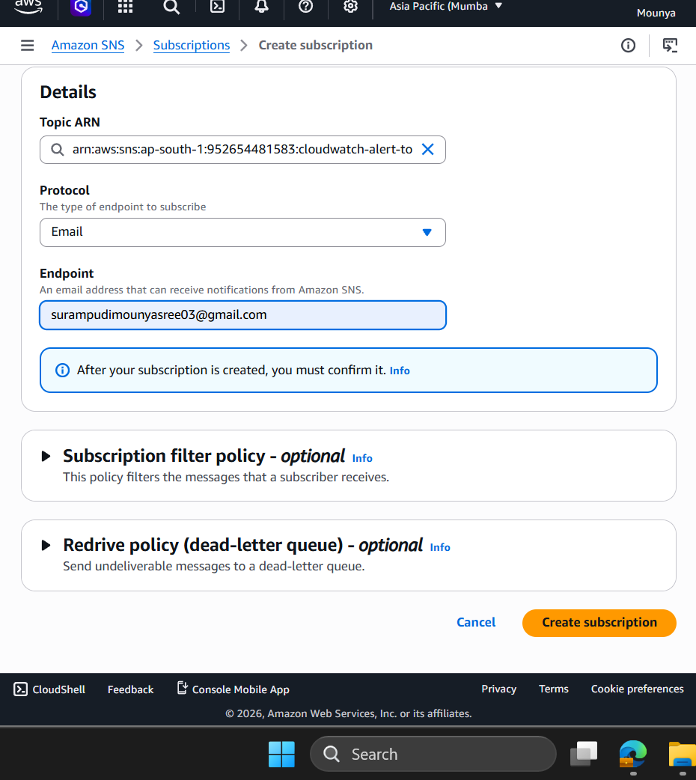

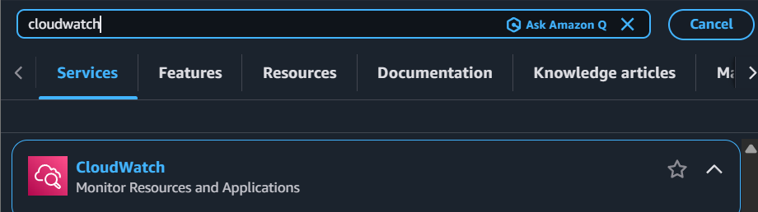
Open CloudWatch Metrics
- Go to CloudWatch
- Click Metrics
You’ll see Namespaces, for example:
- EC2
- EBS
- Lambda
- Linux System (after scripts)

✅ Step 6: Select EC2 metrics
Click:
EC2 → Per-Instance Metrics
Select your instance → CPUUtilization
✅ You see real-time CPU graph
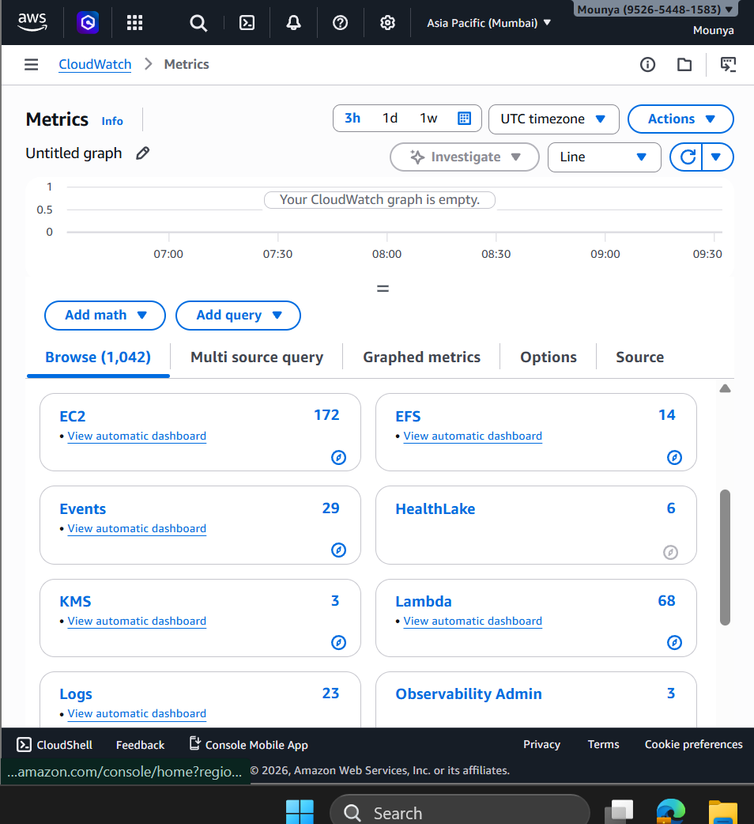

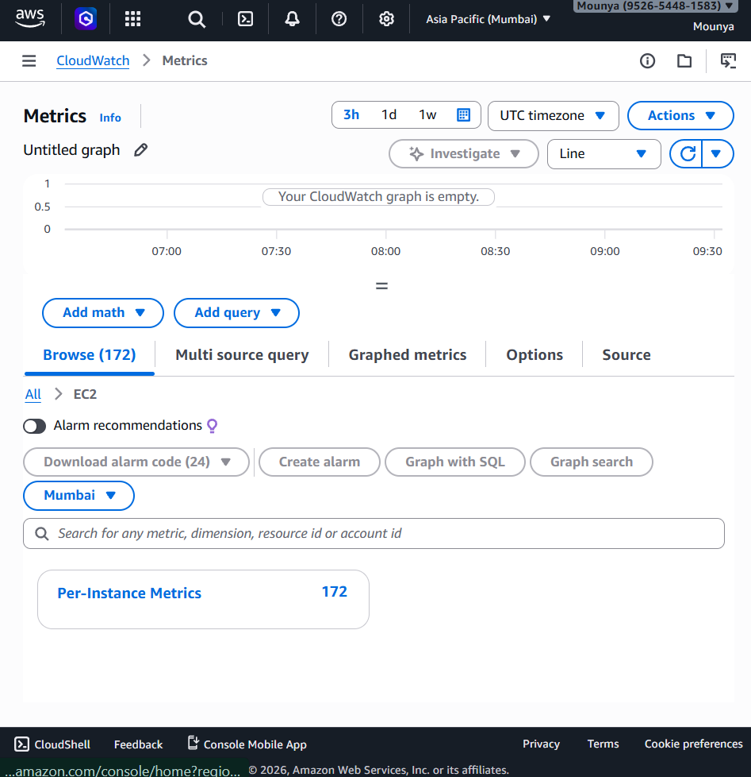

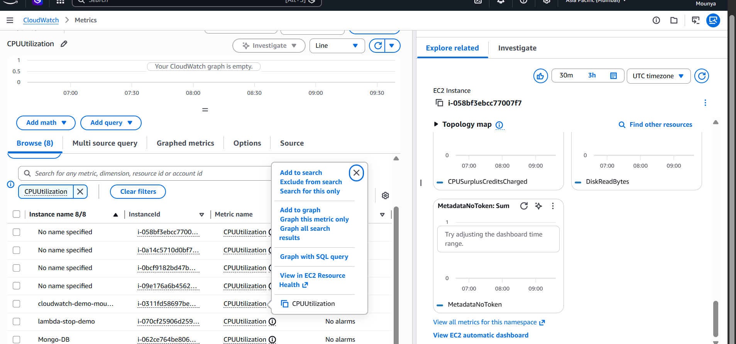
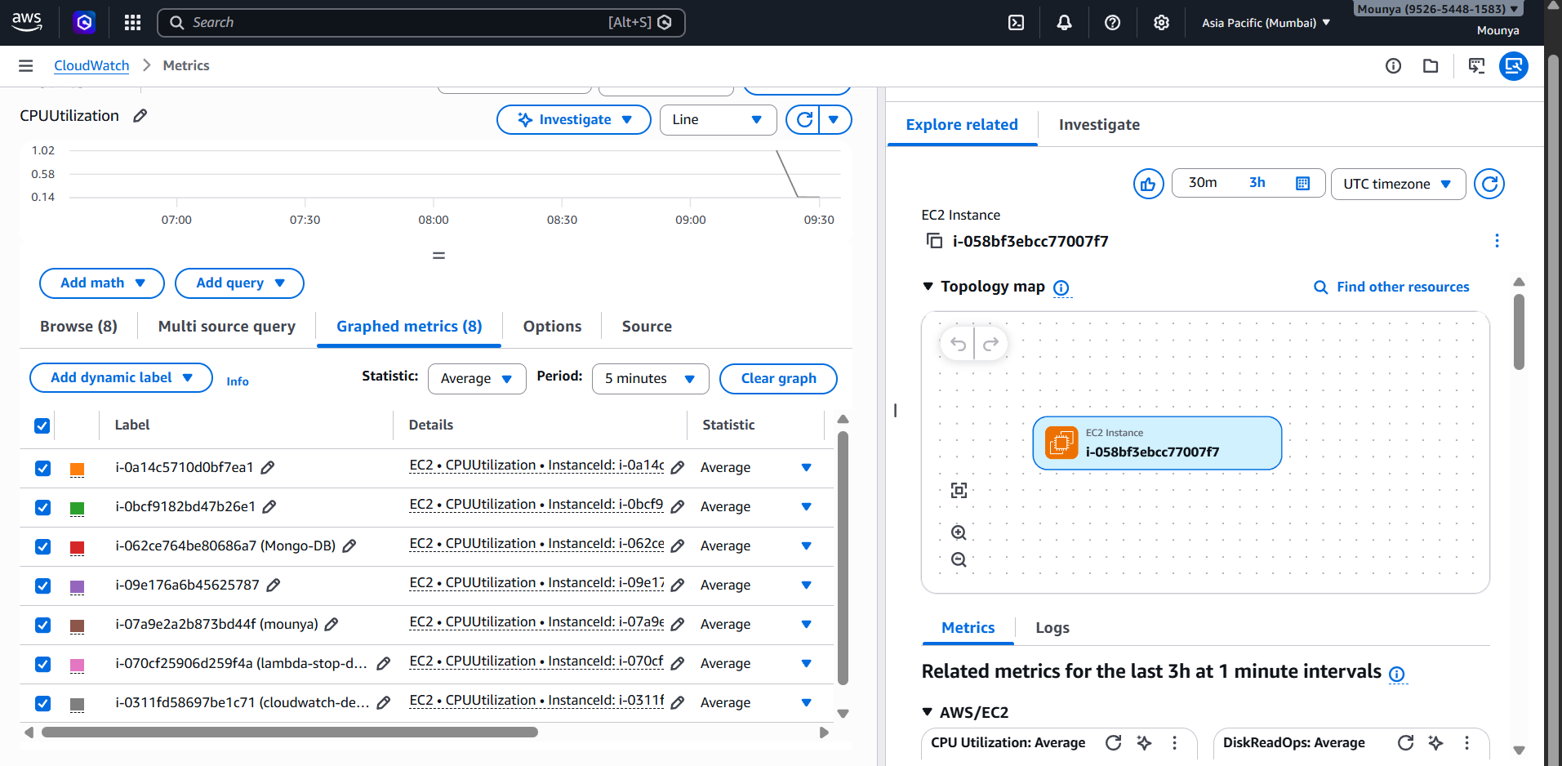
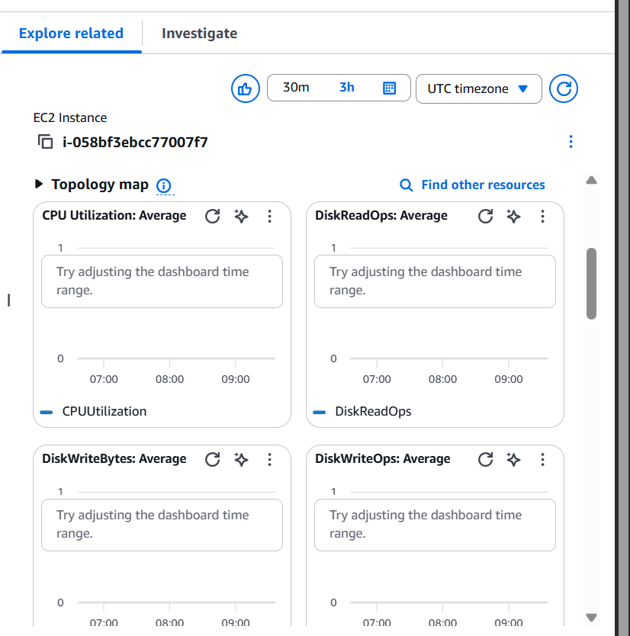

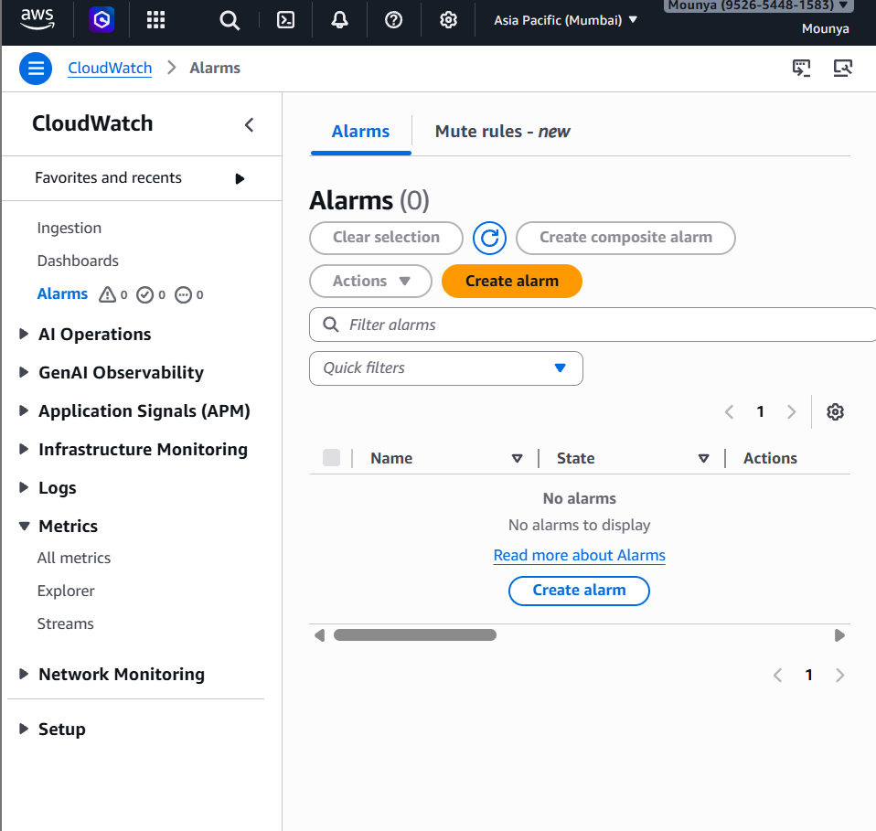
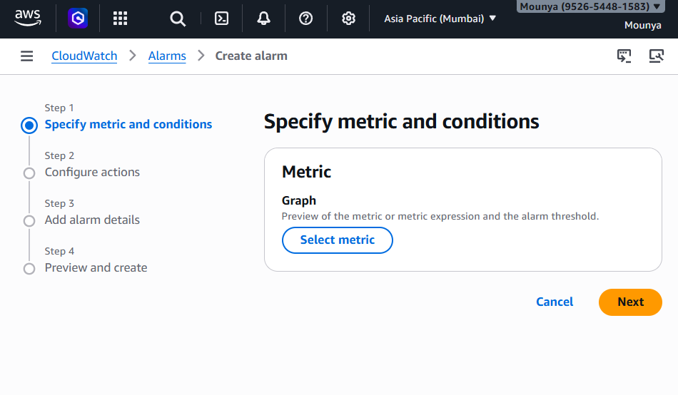
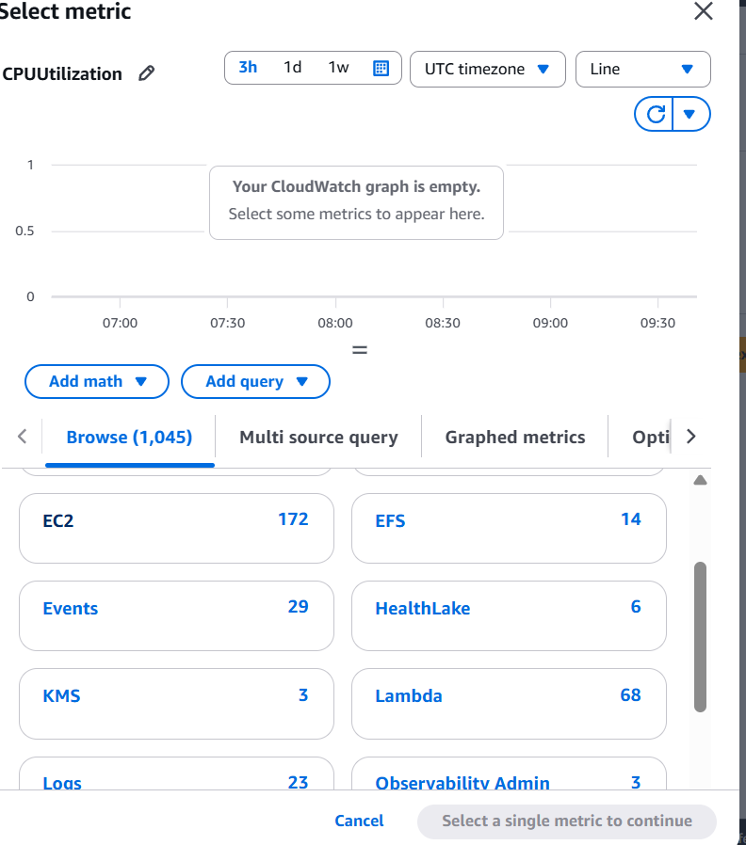
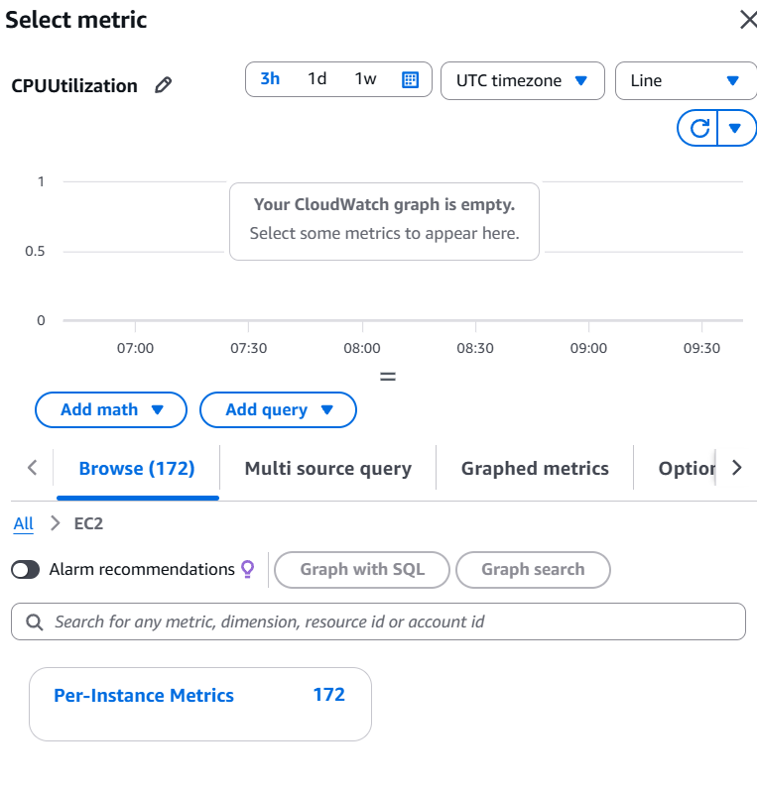
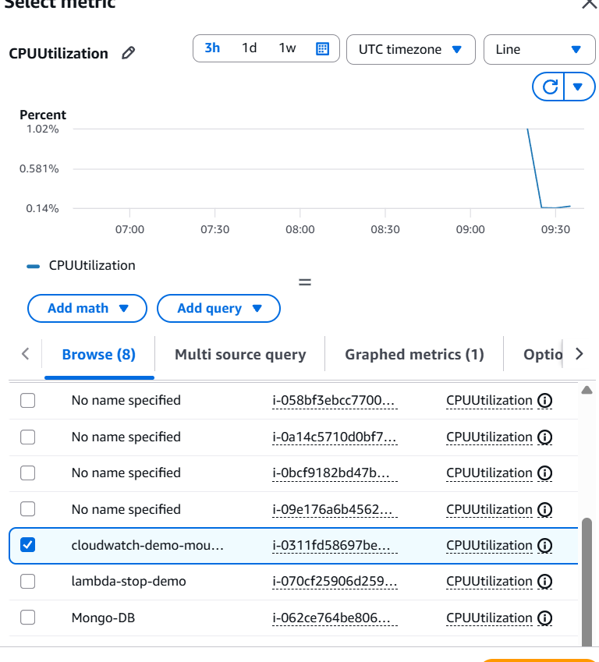
Configure alarm threshold
Set:
- Statistic: Average
- Period: 5 minutes
- Condition:
- CPU Utilization >= 80%
✅ This means:
Alert me if CPU stays high

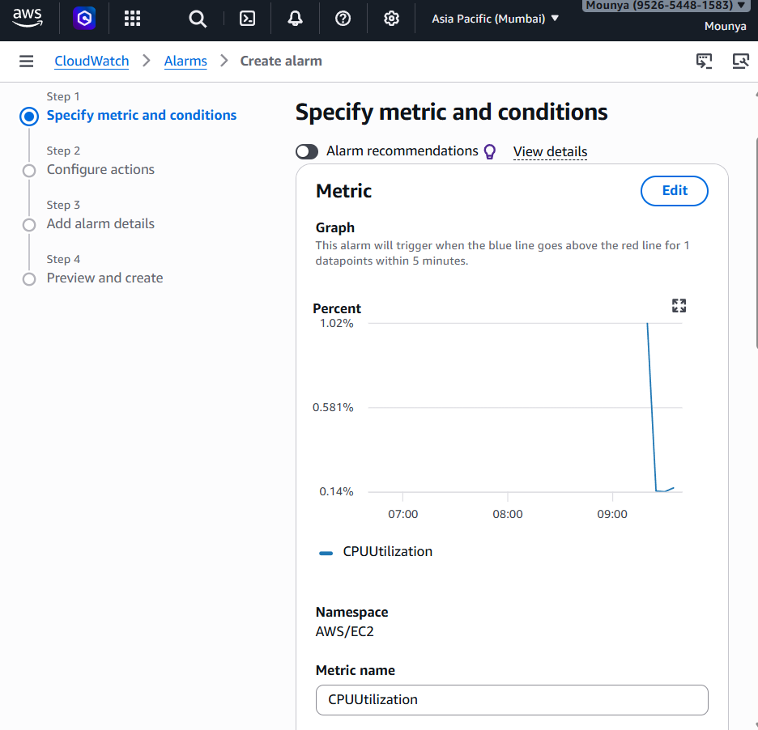
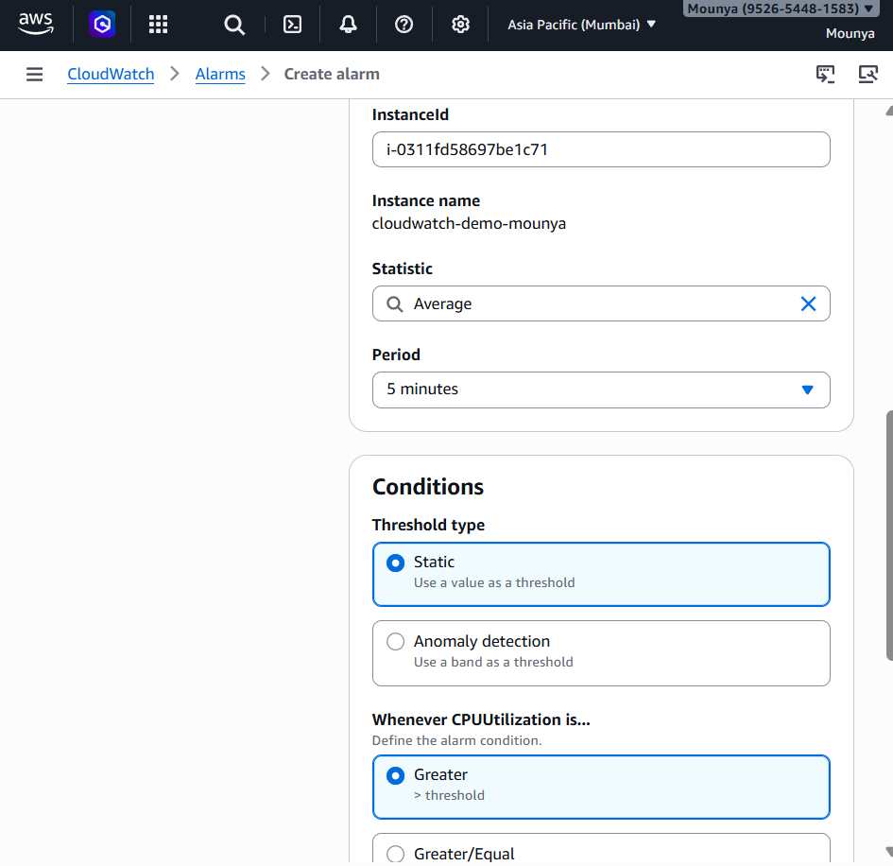
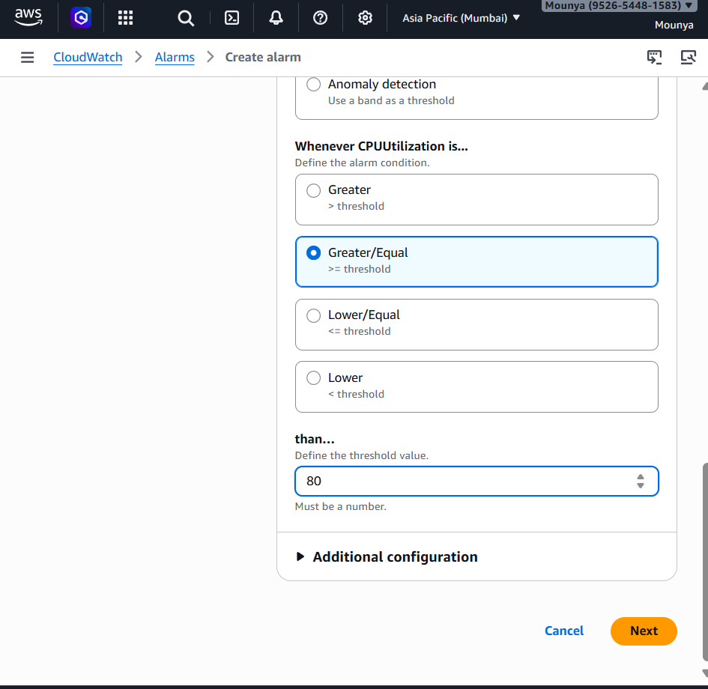
Configure notification
- Select existing SNS topic:
- cloudwatch-alert-topic
- Choose alarm state: In alarm
✅ You’ll receive email when alarm triggers

✅ Step 10: Name and create alarm
- Alarm name:
- HighCPUAlarm
- Click Create alarm

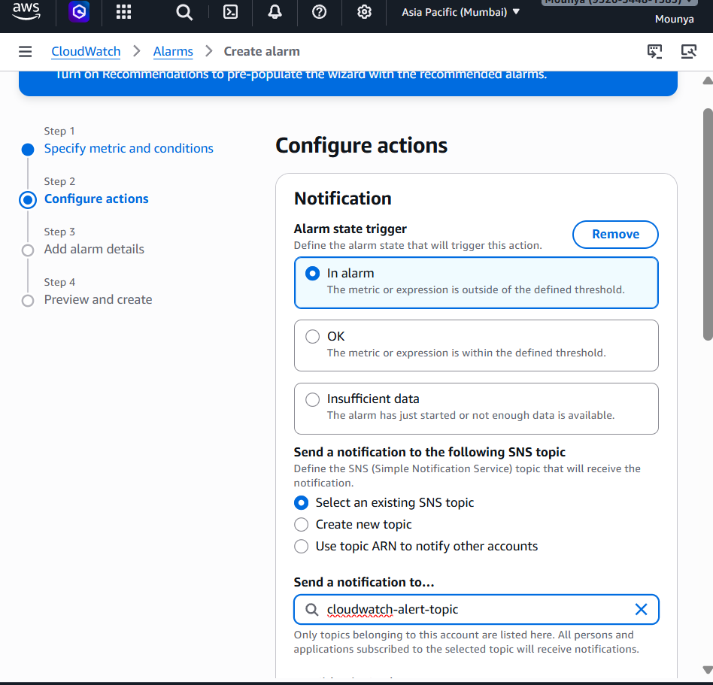
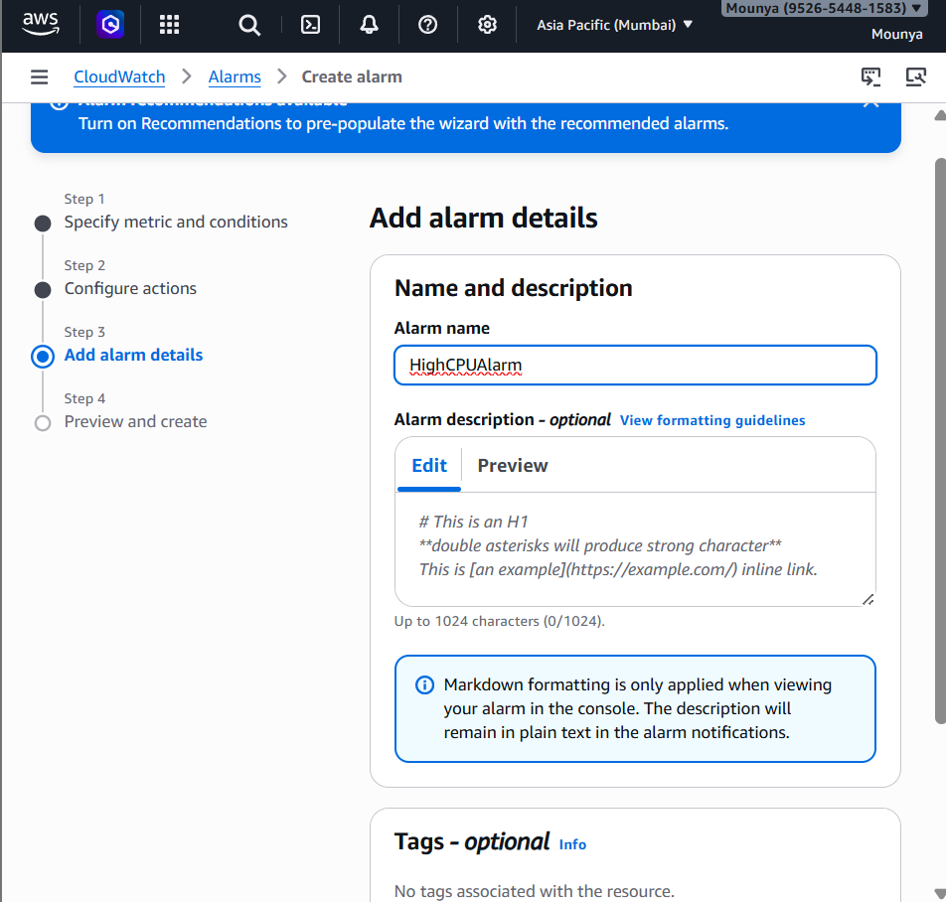

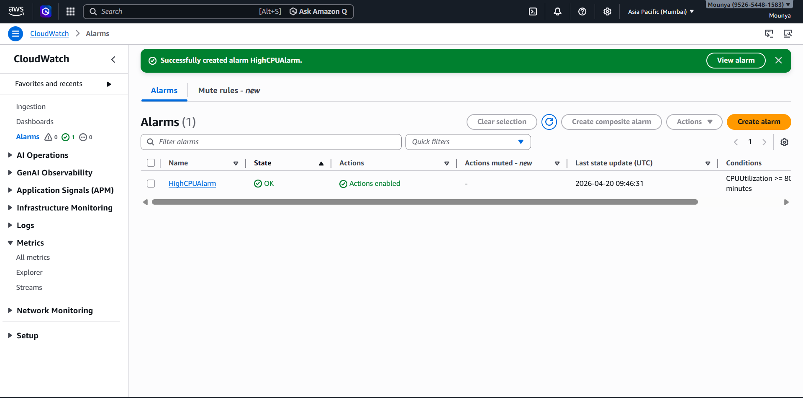

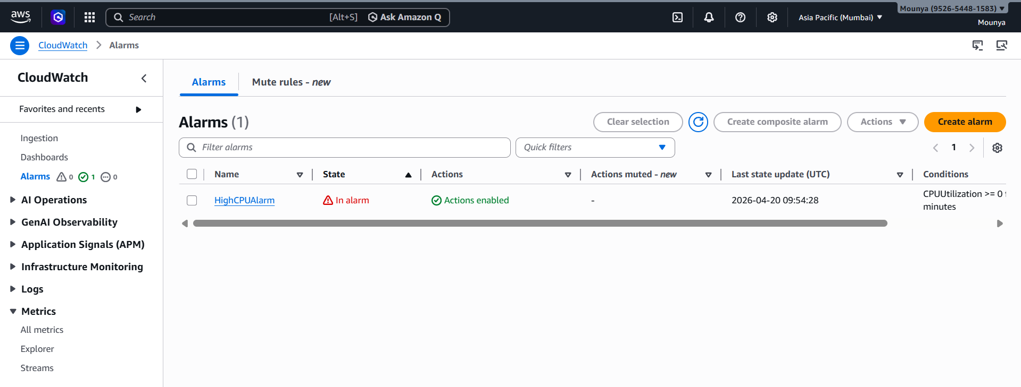
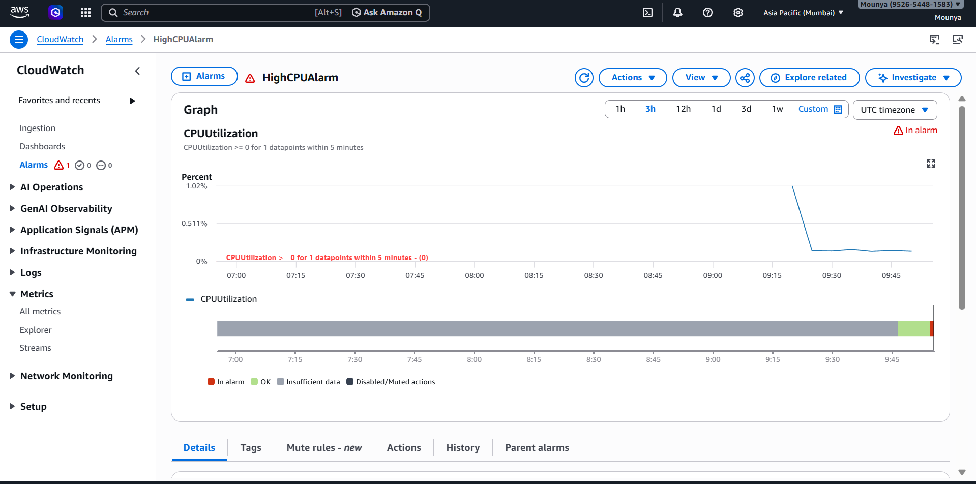
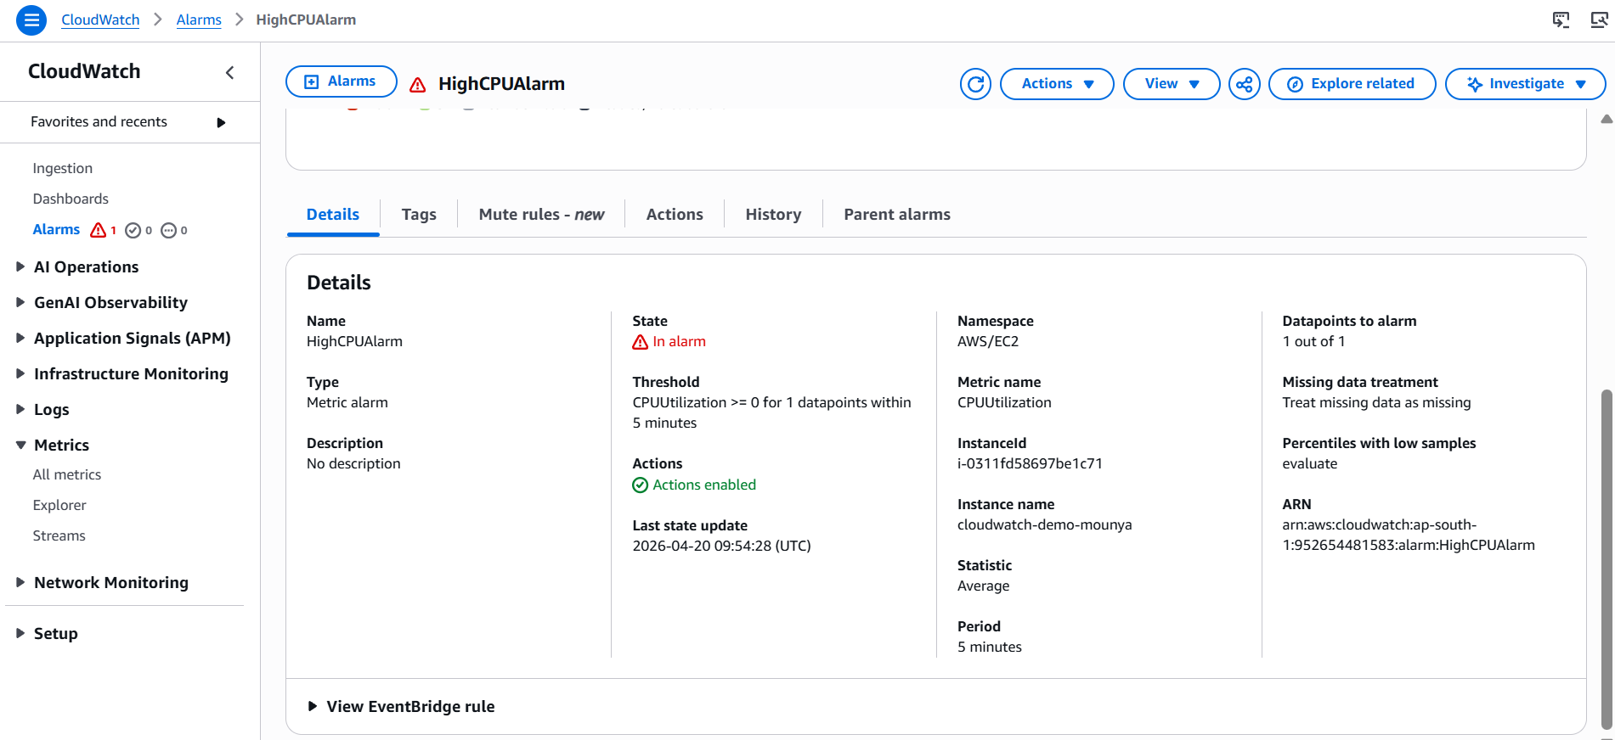
Metric crosses threshold ✅ ↓ Alarm goes to ALARM ✅ ↓ Alarm sends message to SNS ✅ (only if action configured) ↓ SNS sends email ✅ (only if subscription confirmed)

